People Counter with Capacity Control
Project Report, IIT Ropar
GitHub repository: github.com/SanjayButCodes/people_counter_with_capacity_control

1. Group Members
S.No. | Name | Entry Number | Mobile Number
1 | DHONNAR SATYAM RAMESH | 2026AIB1031 | +91 87887 16939
2 | DIVYANSHI | 2026AIB1032 | +91 70921 95363
3 | GAJJELA SRI CHARAN | 2026AIB1033 | +91 92813 72913
4 | GANDRAJUPALLI JATHIN BHARADWAJ | 2026AIB1034 | +91 94928 55101
5 | GANGISHETTY SANJAY DEEP (TL) | 2026AIB1035 | +91 99899 77993

2. Project Title
Smart Room Occupancy Counter (Bidirectional People Counter with Capacity Control)
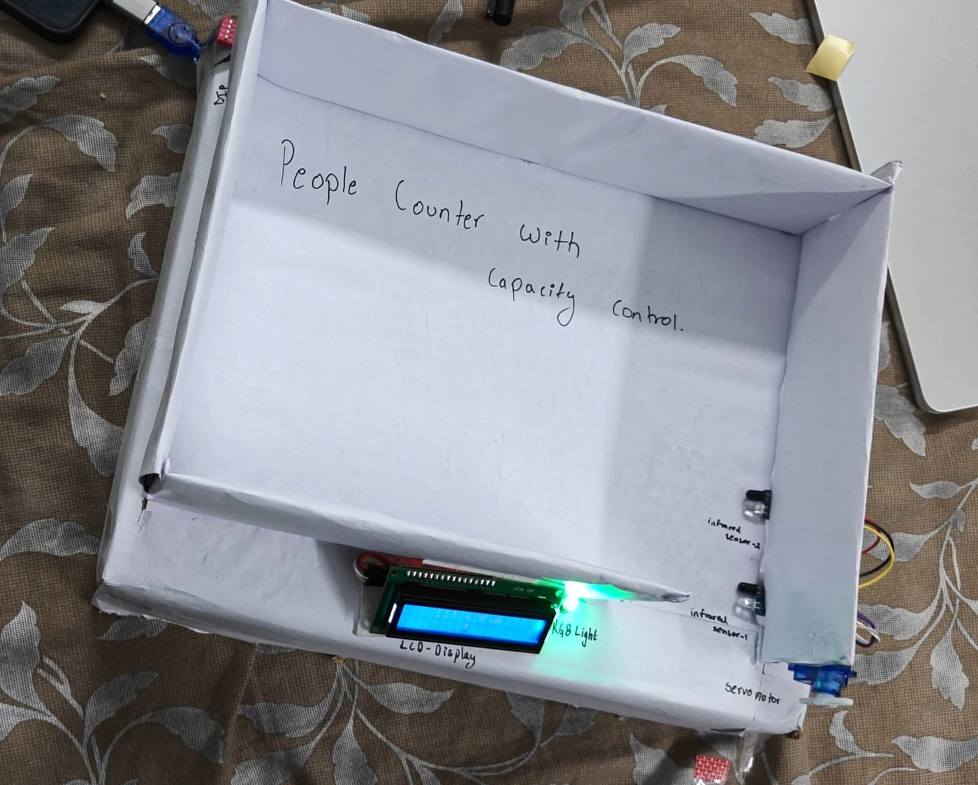
Figure: Working prototype of the Smart Room Occupancy Counter, a box model with the infrared sensors, servo gate, RGB LED and LCD display.

3. Materials Required
S.No. | Component | Quantity | Purpose
1 | Arduino Uno R3 with USB cable | 1 | Main controller
2 | IR obstacle sensor module | 2 | Detect a person and the direction of movement
3 | 16x2 LCD display with I2C module | 1 | Shows the count, capacity and animations
4 | SG90 servo motor | 1 | Gate arm that closes when the room is full
5 | 5V relay module (1 channel) | 1 | Switches ON while someone is inside
6 | RGB LED (common anode) | 1 | Green to red indicator of how full the room is
7 | Active buzzer | 1 | Beeps on entry, exit, reset and denied entry
8 | Push button | 1 | Resets the count to zero
9 | DIP switch | 1 | Sets the room capacity (0 to 7, 0 means no limit)
10 | Resistors (220 ohm) | 2 | Current limiting for the RGB LED
11 | Breadboard | 1 | Circuit assembly
12 | Jumper wires | As needed | Connections

4. Circuit Diagram
The diagram below shows how every component is connected to the Arduino Uno. The pin connection table follows it.
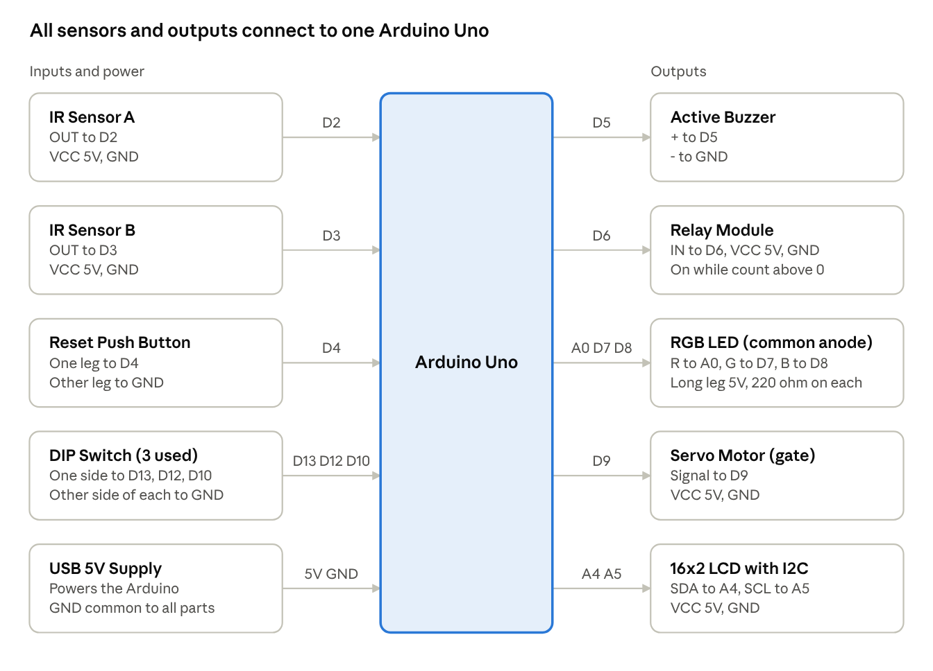
circuit connections · Arduino Uno with 5 inputs and 5 outputs
Inputs and power enter from the left and outputs leave to the right. Every part shares a common GND with the Arduino.
Pin connections
Component | Component pin | Arduino pin
IR Sensor A | OUT | D2
IR Sensor B | OUT | D3
Reset push button | One leg (other leg to GND) | D4
Active buzzer | + (other leg to GND) | D5
Relay module | IN | D6
RGB LED | Green leg | D7
RGB LED | Blue leg (kept off) | D8
RGB LED | Red leg | A0
RGB LED | Common (longest) leg | 5V
Servo motor | Signal | D9
DIP switch (value 1) | One side (other side to GND) | D13
DIP switch (value 2) | One side (other side to GND) | D12
DIP switch (value 4) | One side (other side to GND) | D10
LCD I2C module | SDA | A4
LCD I2C module | SCL | A5
LCD, IR sensors, relay, servo | VCC and GND | 5V and GND
Block diagram
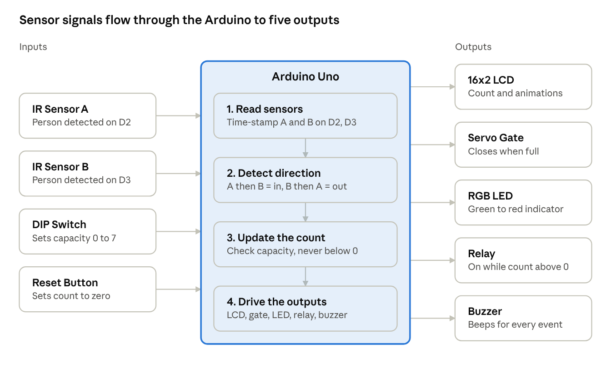
block diagram · 4 inputs, 4 processing steps, 5 outputs
The block diagram shows how a person's movement becomes a count and then drives the five outputs.
Flowchart
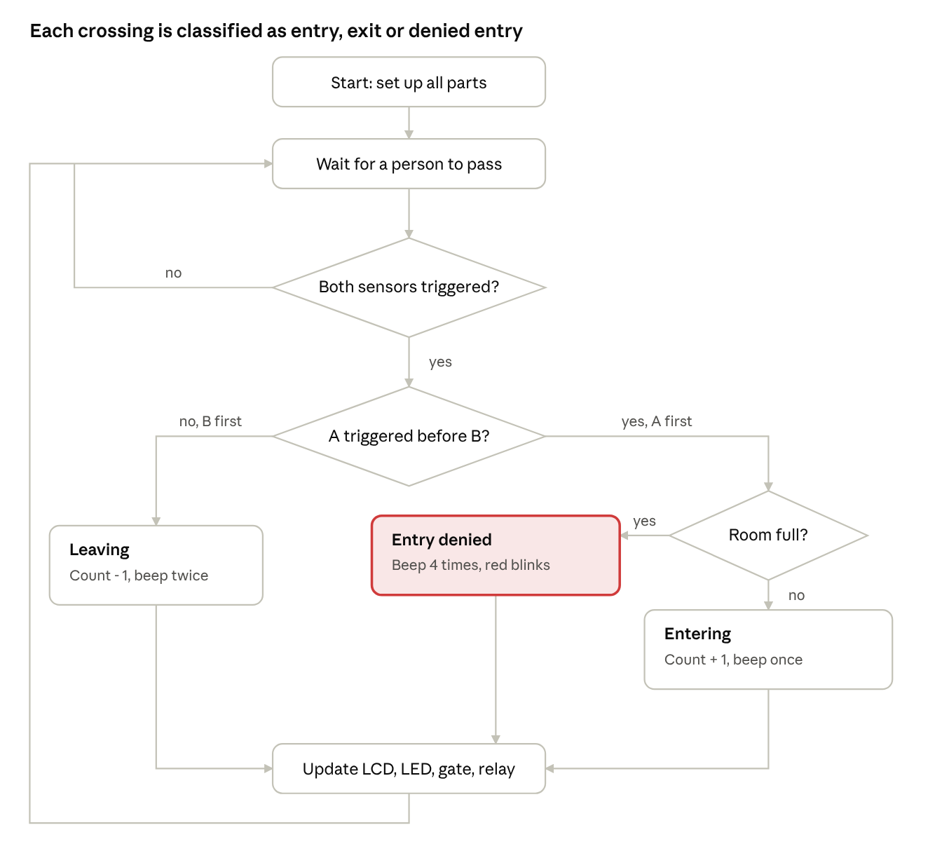
program flowchart · 3 decisions, 3 outcomes
The flowchart follows the program: it waits for both sensors, decides the direction from which one fired first, and applies the capacity rule.

5. Brief Theory and Working
- Two IR sensors, A and B, are fixed one behind the other at the doorway; each sensor output goes LOW when a person blocks its beam.
- The Arduino notes the exact time at which each sensor is triggered, using interrupts on pins D2 and D3.
- If sensor A triggers before B, the person is entering and the count increases by one; if B triggers first, the person is leaving and the count decreases by one (never below zero).
- The room capacity (0 to 7, where 0 means no limit) is set with the DIP switch; when the count reaches it, the servo gate arm closes and any further entry is not counted.
- The RGB LED fades smoothly from green (room empty) through yellow to red (room full), and blinks red when entry is denied.
- The relay switches on only while at least one person is inside the room.
- The 16x2 LCD shows IIT ROPAR when idle, the number inside against the capacity, and animated arrows for entry and exit.
- The buzzer beeps once on entry, twice on exit, four times on denied entry and three times on reset; the push button resets the count to zero.
Detailed theory
The parts below explain each stage of the working in more detail.

5.1 Infrared obstacle sensor
Each IR obstacle sensor module has an infrared LED and a photodiode side by side. The LED sends out infrared light that the eye cannot see. When a person comes in front of the sensor, the light bounces back from the body to the photodiode. A comparator on the module turns this reflected light into a digital signal: the output pin stays HIGH when nothing is near and goes LOW when a person is detected. A small potentiometer on the module sets how close an object must be before it is detected.

5.2 Direction detection
The two sensors are placed one behind the other along the path of walking, so a person always blocks one ray before the other. Both sensor pins are connected to interrupt pins (D2 and D3), so the Arduino reacts the instant a signal falls from HIGH to LOW and saves the time in microseconds.
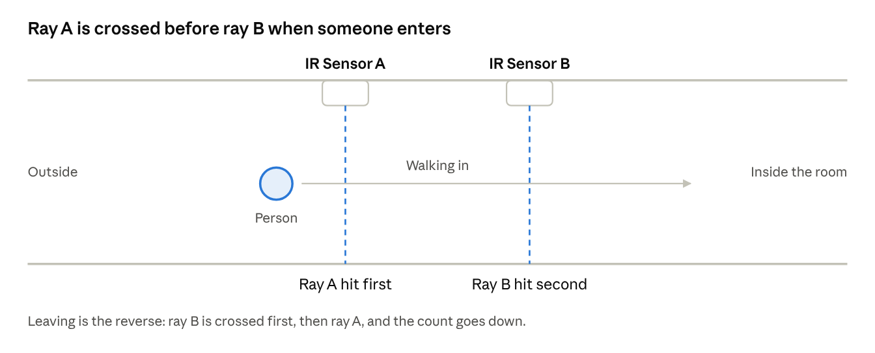
ray diagram · doorway seen from above
Comparing the two saved times gives the direction. If A is earlier than B the person is entering, and if B is earlier than A the person is leaving.
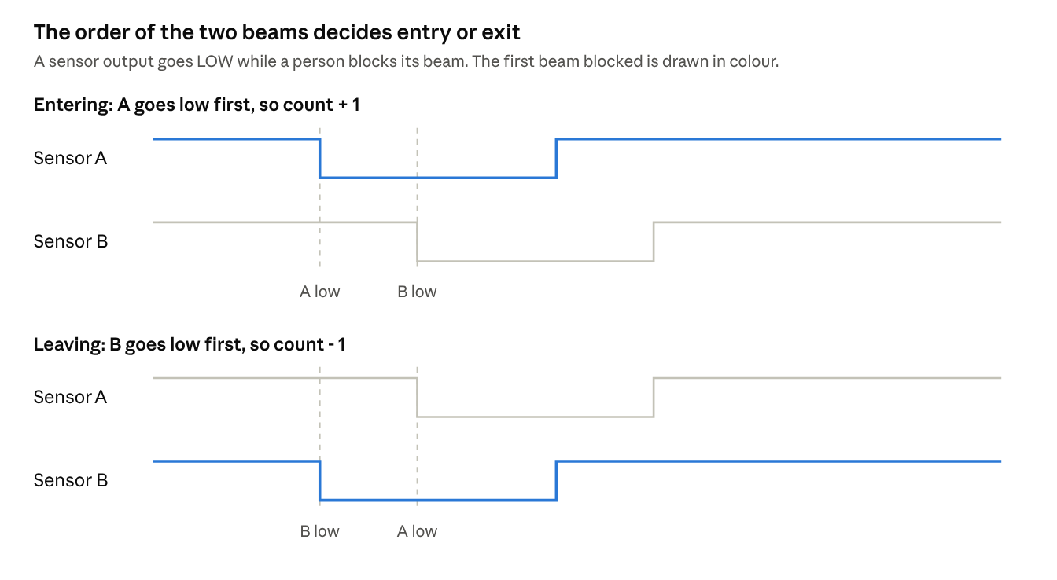
sensor timing · entering and leaving
After a count, the program waits until both sensors are clear again before accepting the next person, so one person is never counted twice. If only one sensor triggers and the other does not follow within 2 seconds, the program treats it as a half crossing and ignores it.

5.3 Capacity control and the gate
The three DIP switches form a binary number from 0 to 7, which is the maximum number of people allowed inside. A switch that is ON connects its pin to GND, which the program reads as 1. A value of 0 means no limit. The program reads the switches every 0.2 seconds, so the capacity can be changed while the system is running.
When the count reaches the capacity, the servo moves the gate arm smoothly from 90 degrees (open) to 0 degrees (closed). Anyone who still crosses in is not counted and the buzzer beeps four times. People can still leave, and the gate opens again as soon as the count falls below the capacity.

5.4 RGB LED indicator
The LED shows how full the room is as a percentage: fullness = count / capacity x 100. Below 50 percent the red part rises from 0 to full while green stays full, so the colour moves from green to yellow. Above 50 percent the green part falls from full to 0 while red stays full, so the colour moves from yellow to red. The colour changes in small steps every 10 ms, which gives a smooth fade. If no capacity is set, the LED stays green.
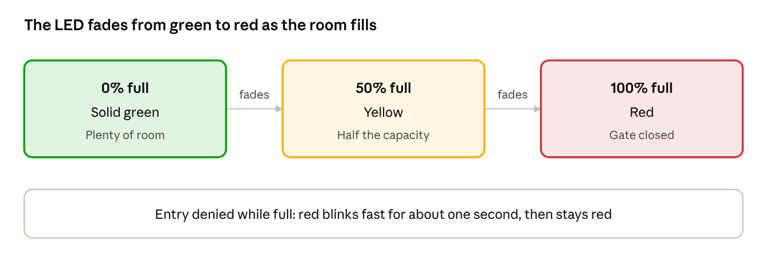
LED colour states · green, yellow, red
The LED is common anode, so a colour lights up when its pin is driven LOW. The LED pins are not hardware PWM pins, so the brightness is produced by software PWM using Timer2 (about 4000 interrupts per second with 32 brightness levels), which looks steady to the eye.

5.5 Relay
The relay module works as an electronic switch. The Arduino pin only has to drive the relay input, and whatever is connected to the relay contacts stays electrically separate from the Arduino. The relay module used is active LOW, so the program drives D6 LOW to switch the relay on. The relay is on only while the count is above zero and off when the room is empty.

5.6 Display, buzzer and reset
The 16x2 LCD is connected through an I2C module, so only two signal wires (SDA and SCL) are needed. At start-up the program checks the addresses 0x27 and 0x3F to find the display. It rewrites only the characters that changed, which keeps the animations smooth and free of flicker. At rest it shows IIT ROPAR and alternates between a walking figure and the number inside against the capacity.
The buzzer gives one beep for an entry, two for an exit, four for a denied entry and three for a reset. The push button clears the count to zero after a 30 ms debounce check.

6. Team Contributions
Member | Work done
GANGISHETTY SANJAY DEEP (Team Leader) | Sourced and ordered the materials, made the report, made the circuit and wrote the code
DIVYANSHI | Sourced and ordered the materials and made the report
GANDRAJUPALLI JATHIN BHARADWAJ | Made the circuit and wrote the code
GAJJELA SRI CHARAN | Made the model, rewired the circuit and decorated the model
DHONNAR SATYAM RAMESH | Made the model, rewired the circuit and decorated the model

